System level tests

I want a table that has a list of test cases you are testing and whether each passed or failed.  8 - 10 detailed test cases is the number I am looking for.

<https://www.youtube.com/watch?v=3lOjtmsA2Kk>

<http://softwaretestingfundamentals.com/system-testing/>

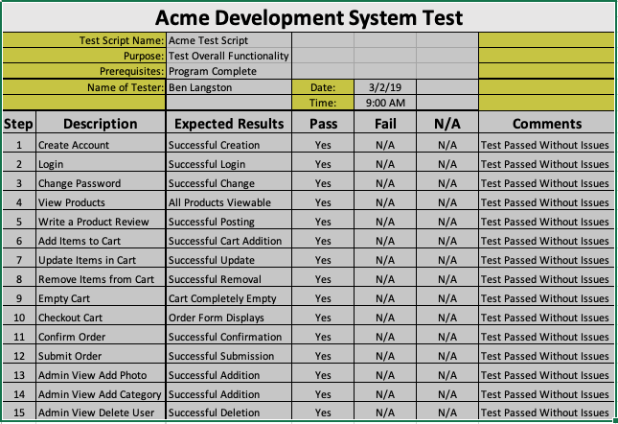

|  |
| --- |
| Graphical user interface testing |
|  | Usability testing |
|  | Software performance testing |
|  | Compatibility testing |
|  | Exception handling |
|  | Load testing |
|  | Volume testing |
|  | Stress testing |
|  | Security testing |
|  | Graphical user interface testing |
|  | Usability testing |
|  | Software performance testing |
|  | Compatibility testing |
|  | Exception handling |
|  | Load testing |
|  | Volume testing |
|  | Stress testing |
|  | Security testing |

<https://www.youtube.com/watch?v=PfXt-iEq0qM&feature=youtu.be>